Lori McMillan

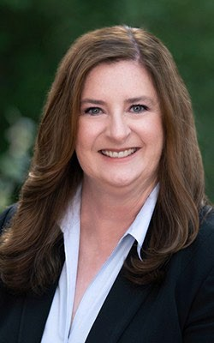
www.linkedin.com/in/lori-mcmillan-155280/

Lori McMillan is a business-oriented, public company, human capital transformational leader highly skilled in developing and scaling diverse high-performance teams while strengthening retention, engagement, and culture and optimizing employee and operational performance. She provides expertise to board committees in crucial areas, including strategic planning, compensation, compliance, governance, executive recruitment, and talent strategies that enable the achievement of corporate objectives while promoting organizational efficiencies, inclusion, agility, and productivity.
During her 20-year career as a human capital executive, she has driven rapid growth and engagement across companies in healthcare and technology. As VP of HR at Viveve Medical, Inc., she doubled the headcount in her first eight months, and average retention is 88% in the last four years. Her crisis leadership, adaptability, and risk management during the unprecedented challenges of the pandemic have proven her strategic and tactical abilities as a vital member of the executive team. Lori increased headcount 100% at The Breakaway Group during post-acquisition integration with Xerox and managed the corporate relocation. She provided strategic focus to human capital utilizing technology at AORN to grow the organization and increase efficiency, engagement, inclusion, and retention. At Evolving Systems, Inc., she successfully scaled the workforce and collaborated with the executive team in positioning the company for the IPO.
Lori develops business partnerships with senior executives, founders, and leaders at all levels and leads complex change in fast-paced environments. She orchestrated restructuring efforts at multiple companies to align with business needs, recently reducing annual G&A expenses by 39%.
Early in her career, Lori developed strong business acumen through sales executive and strategic account management experience with Estee Lauder and Riviera Concepts, where she received numerous awards for exceptional sales achievement and customer service. Lori is a graduate and athletic scholarship recipient of Colorado State University and a certified HR professional (inactive). She is considered a strong communicator, critical thinker, and collaborative leader.

